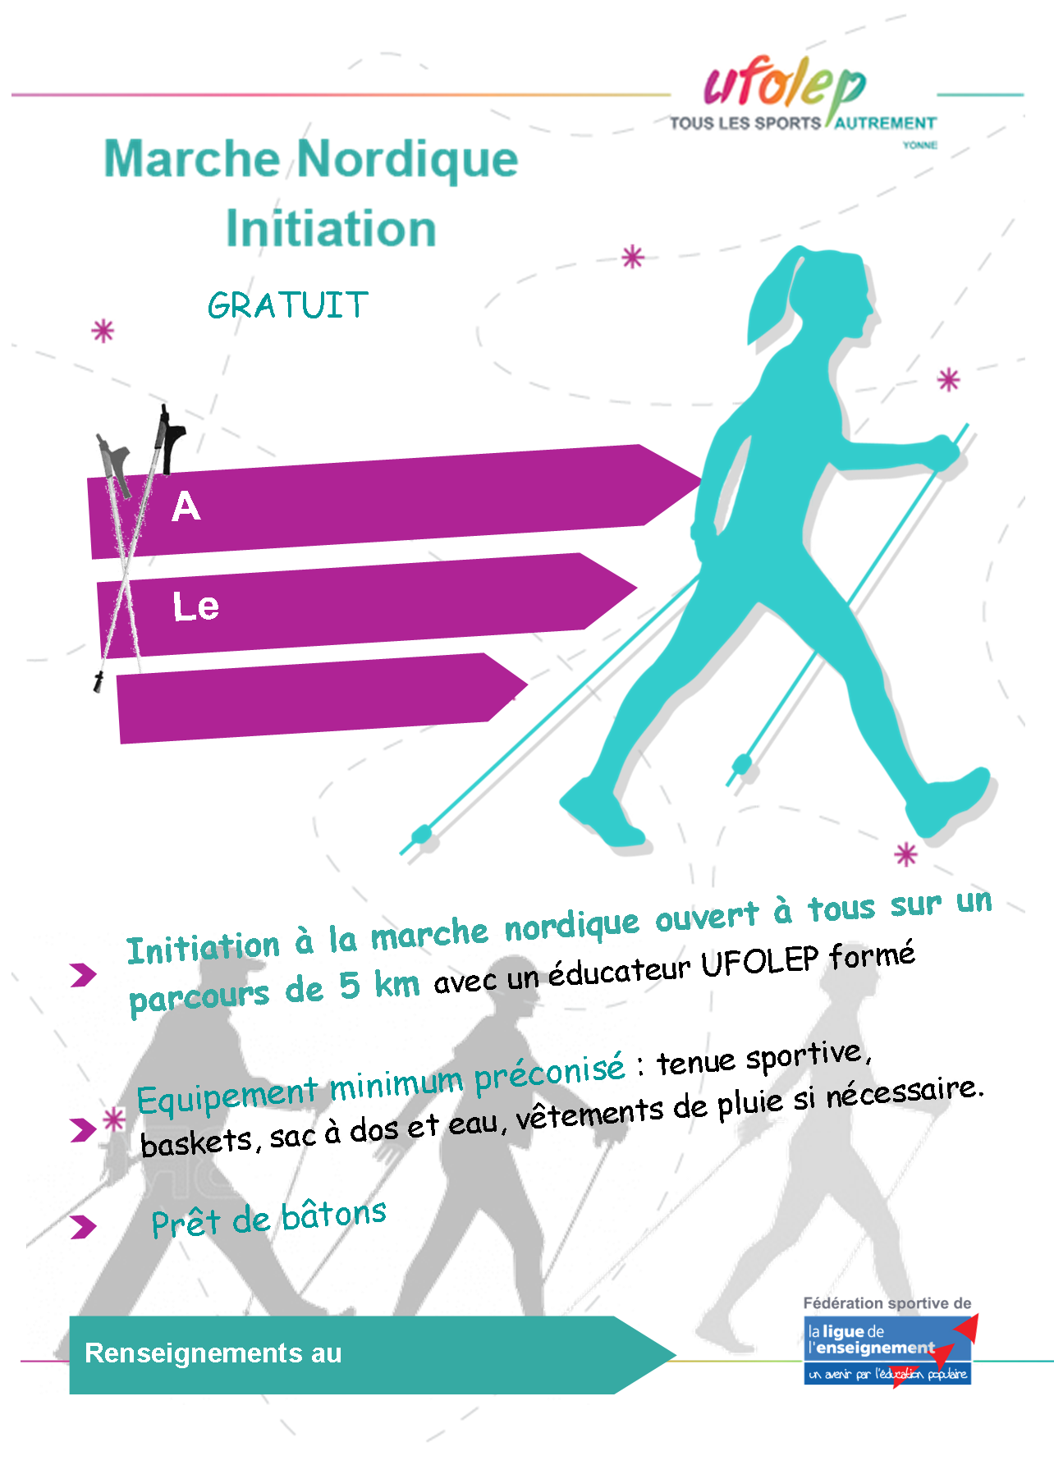

**XXXXXX**

**XXXXXXX**

**XXXXXX**

LOGO asso

**03 86 xx xx xx**

**00**

**10**